Notes in ‘New Project - 2/24/26, 14:45’

Notes in Document
'A predictive processing perspective of disrupted motor control under anxiety .pdf':

Highlight : Within PP accounts, anxiety – which is traditionally described as a negative emotional response to threat consisting of cognitive worry and physiological arousal (Eysenck, 2013) – is recast as a state of hypervigilance where the world is viewed as more uncertain and the agent can no longer predict the absence of threats with confi dence (Cornwell et al., 2017; Grupe and Nitschke, 2013).
(A predictive processing perspective of disrupted motor control under anxiety .pdf, p.3)

Highlight : Clark, Watson, and Friston (2018) describe anxiety not only as a state of uncertainty, but as a generalised expectation of uncertainty (about potential threats in the world and our ability to anticipate them) that is held with low precision.
(A predictive processing perspective of disrupted motor control under anxiety .pdf, p.4)

Highlight : As a result, anxious agents seek to reduce the perceived unpredictability of the world, and the associated uncertainty about their perceptions, either through action or revising their beliefs.
(A predictive processing perspective of disrupted motor control under anxiety .pdf, p.4)

Highlight : one strategy to resolve un certainty about negative outcomes is increased attention to threat-related cues (Bar-Haim et al., 2007). But attention to threat-related cues only serves to further increase estimates of the likelihood of negative outcomes, which further perpetuates feelings of anxiety and the persistence of perceived uncertainty
(A predictive processing perspective of disrupted motor control under anxiety .pdf, p.4)

Highlight : N1 responses were strongly correlated
(A predictive processing perspective of disrupted motor control under anxiety .pdf, p.4)

Highlight : Combined, we believe that these findings provide strong evidence for
(A predictive processing perspective of disrupted motor control under anxiety .pdf, p.4)

Highlight : an up-weighting of sensory input (and a concomitant reduction in the precision afforded to prior beliefs about stability) during situations of high uncertainty about stability. This has the effect of allowing even small prediction errors to ascend to higher levels of the nervous system, leading to changes in perceptions of stability. In other words, deviations in stability will be perceived more easily, resulting in the triggering of rapid, reflexive actions to counteract the perceived postural disturbance and minimise the error signal.
(A predictive processing perspective of disrupted motor control under anxiety .pdf, p.5)

Notes in Document
'Neuroanatomy, Somatosensory Cortex - StatPearls - NCBI Bookshelf.pdf':

Highlight : postcentral gyrus,
(Neuroanatomy, Somatosensory Cortex - StatPearls - NCBI Bookshelf.pdf, p.1)

Highlight : adaptation. Different receptor types experience different degrees of adaptation and extinction. Quickly-adapting receptors (phasic) tend to adjust more quickly and send signals more frequently with changes in intensity, such as during the onset and offset of the stimulus. Phasic receptors are more important in vestibular senses, which tend to respond to changes in our body position for balance.
(Neuroanatomy, Somatosensory Cortex - StatPearls - NCBI Bookshelf.pdf, p.3)

Highlight : proprioception,
(Neuroanatomy, Somatosensory Cortex - StatPearls - NCBI Bookshelf.pdf, p.3)

Highlight : The proprioception receptors exist within the skeletal muscles and tendons and assist in understanding the locations of the body in space.
(Neuroanatomy, Somatosensory Cortex - StatPearls - NCBI Bookshelf.pdf, p.4)

Highlight : walking. The sensory receptors involved in proprioception include the muscle spindle and the Golgi tendon organ.
(Neuroanatomy, Somatosensory Cortex - StatPearls - NCBI Bookshelf.pdf, p.4)

Highlight : by gamma (A- gamma) motor neurons
(Neuroanatomy, Somatosensory Cortex - StatPearls - NCBI Bookshelf.pdf, p.4)

Notes in Document
'The Altered Somatic Brain Network in State Anxiety.pdf':

Highlight : In this study, we investigated the relationship between state anxiety and the spontaneous brain activity of the somatosensory cortex in a non-clinical healthy population with state anxiety. Furthermore, we also explored the functional connections of the somatosensory cortex. We found that state anxiety was positively correlated with the amplitude of low-frequency fluctuations (ALFFs) of somatic related brain regions, including the right postcentral gyrus (somatosensory cortex) and the right precentral gyrus (somatic motor cortex). Furthermore, we found that state anxiety was positively correlated with the connections between the postcentral gyrus and the left cerebellum gyrus, whereas state anxiety was negatively correlated with the connectivity between the postcentral gyrus and brain regions including the left inferior frontal cortex and left medial superior frontal cortex. These results revealed the association between the anxious individuals’ body-loop and state anxiety in a healthy population, which revealed the importance of somatic brain regions in anxiety symptoms and provided a new perspective on anxiety for further study.
(The Altered Somatic Brain Network in State Anxiety.pdf, p.1)

Notes in Document
'Quantitative assessment of human-exoskeleton integration through a neurophysiological marker of embodiment.pdf':

Highlight : The more expected movement and actual movement match (i.e., spatiotemporal congruency), the more the subject experiences a sense of agency over that movement, a sense of self-location with the body part or tool used, and a sense of ownership over the action. In contrast, a consistent mismatch will lead to a decreased tool embodiment
(Quantitative assessment of human-exoskeleton integration through a neurophysiological marker of embodiment.pdf, p.2)

Highlight : Until now, exoskeleton embodiment has been largely overlooked,
(Quantitative assessment of human-exoskeleton integration through a neurophysiological marker of embodiment.pdf, p.2)

Highlight : exoskeleton. More specifically, N60 amplitudes over the somatosensory area were higher in the exoskeleton conditions compared to the corresponding non-exoskeleton conditions.
(Quantitative assessment of human-exoskeleton integration through a neurophysiological marker of embodiment.pdf, p.7)

Highlight : In our study, we did not expect to observe embodiment between the exoskeleton and the user, given the characteristics of the exoskeleton (e.g., bulkiness, rigidity) and the lack of prior familiarization with it20.
(Quantitative assessment of human-exoskeleton integration through a neurophysiological marker of embodiment.pdf, p.7)

Highlight : it20. However, sensory attenuation, albeit with a lesser degree than in the non-exoskeleton condition, was still observed when wearing the exoskeleton.
(Quantitative assessment of human-exoskeleton integration through a neurophysiological marker of embodiment.pdf, p.7)

Highlight : type, the N60 amplitudes were less attenuated when the participant wore the exoskeleton
(Quantitative assessment of human-exoskeleton integration through a neurophysiological marker of embodiment.pdf, p.7)

Highlight : user has not developed an accurate internal model of the exoskeleton’s dynamics
(Quantitative assessment of human-exoskeleton integration through a neurophysiological marker of embodiment.pdf, p.7)

Highlight : perception, even when participants were not required to move
(Quantitative assessment of human-exoskeleton integration through a neurophysiological marker of embodiment.pdf, p.7)

Highlight : general alteration of body control perception
(Quantitative assessment of human-exoskeleton integration through a neurophysiological marker of embodiment.pdf, p.7)

Highlight : move.
(Quantitative assessment of human-exoskeleton integration through a neurophysiological marker of embodiment.pdf, p.7)

Highlight : move. This suggests that wearing an exoskeleton could lead to a sense of disembodiment, even without movement.
(Quantitative assessment of human-exoskeleton integration through a neurophysiological marker of embodiment.pdf, p.7)

Highlight : In this context, it is crucial to emphasize that factors such as the weight of the exoskeleton are not confounding variables, but rather a central component of the sensorimotor experience
(Quantitative assessment of human-exoskeleton integration through a neurophysiological marker of embodiment.pdf, p.7)

Highlight : ALICE exoskeleton
(Quantitative assessment of human-exoskeleton integration through a neurophysiological marker of embodiment.pdf, p.7)

Highlight : attentional processes
(Quantitative assessment of human-exoskeleton integration through a neurophysiological marker of embodiment.pdf, p.7)

Highlight : the greater mismatch between predicted and actual sensory input in these conditions likely increases demands on attentional resources.
(Quantitative assessment of human-exoskeleton integration through a neurophysiological marker of embodiment.pdf, p.7)

Highlight : this, a qualitative study found that simply wearing a heavy exoskeleton makes users constantly aware of the device, heightening their overall sensory awareness
(Quantitative assessment of human-exoskeleton integration through a neurophysiological marker of embodiment.pdf, p.7)

Highlight : contrast, in non- exoskeleton conditions, more accurate sensorimotor predictions reduce the need for such attentional shifts, leading to diminished modulation of perceived stimulus intensity.
(Quantitative assessment of human-exoskeleton integration through a neurophysiological marker of embodiment.pdf, p.7)

Highlight : Research on attention orienting in the somatosensory modality has shown that the N100 is a marker of attention orientation to external somatosensory stimuli, which mediates the perception of stimulus intensity
(Quantitative assessment of human-exoskeleton integration through a neurophysiological marker of embodiment.pdf, p.7)

Highlight : In this study, the N100 was significantly more negative in the external stimulation conditions compared to self- stimulation, regardless of the presence of the exoskeleton. These results likely reflect the natural tendency to focus on external stimuli, which are perceived as more evolutionarily significant than self-generated stimuli and, as a result, are subjectively experienced as more intense.
(Quantitative assessment of human-exoskeleton integration through a neurophysiological marker of embodiment.pdf, p.7)

Notes in Document
'Learned uncertainty The free energy principle in anxiety.pdf':

Highlight : To be precise, momentary anxiety can be thought of as generated via high entropy probability distributions within a single perception-action cycle, whereas anxious “beliefs” form based upon low entropy probability distributions of those “observations of observations” (i.e., meta observations, or level 2 of the hierarchical model), the composition of which are more uncertain probability distributions.
(Learned uncertainty The free energy principle in anxiety.pdf, p.7)

Notes in Document
'Embodiment_for_Robotic_Lower-Limb_Exoskeleton.pdf':

Highlight : A scientific study on efference and reafference, or a sensory response due to the subject’s own actions, that is of particular importance to robotic exoskeletons involves subjects tickling themselves. Humans generally cannot tickle themselves because they can predict the sensory feedback from the tickling, muting the response [64]. Blakemore et al. used a robotic apparatus so that subjects moved a manipulandum with one hand that moved another robotic manipulandum that tickled the second arm [65]. Even with the robotic interface, the tickling response was muted. However, when introducing a delay between the subject’s motor command the tickling sensation increased. Even with just a 100 ms delay, the subjects reported significantly greater tickle feeling than when the movement was not delayed. The increased tickle reaction occurred because the delay induced a mismatch between the forward model prediction of sensory feedback and the actual sensory feedback [65].
(Embodiment_for_Robotic_Lower-Limb_Exoskeleton.pdf, p.4)

Highlight : If the user does not have agency over the controller or the controller is not transparent to the user, the user would have a more difficult time developing (an) appropriate internal model(s) to reflect the altered limb dynamics with the exoskeleton
(Embodiment_for_Robotic_Lower-Limb_Exoskeleton.pdf, p.5)

Highlight : The amount of cognitive load required to use an exoskeleton should not cause an increase in errors or a decrease in function in other important daily tasks
(Embodiment_for_Robotic_Lower-Limb_Exoskeleton.pdf, p.5)

Highlight : Proprioceptive drift
(Embodiment_for_Robotic_Lower-Limb_Exoskeleton.pdf, p.6)

Highlight : Current exoskeleton controllers do not incorporate these types of modifications in high-level and low-level control. Historically, exoskeleton developers have focused on high- level controllers for exoskeleton dynamics. Sensors on the exoskeleton have used kinematic or kinetic feedback to determine the general task intended by the user, and then activated the motors/actuators to assist the human motion. Increased consideration of both high- and low-level controls would enable exoskeletons to better coordinate with the human nervous system and likely increase the embodiment of devices. Increased movement variability by an exoskeleton user may make it harder for the exoskeleton to decipher the user’s intent [99][68]. Discord between the human’s intended movement and the exoskeleton assistance/resistance would likely be registered as an error by the nervous system, requiring adjustments to existing internal models. An exoskeleton that only uses joint kinematics in a traditional state-based controller to coordinate actuator torque would miss changes in impedance and muscle activation that accompany change in terrain for example [100]. Incorporating sensors that directly measure muscle activation (electromyography or EMG) may better allow an exoskeleton to make adjustments in line with the user’s intent. Coordination of the high and low-level biological and robotic systems is necessary to create an exoskeleton that can cooperate with the user during low and high variability movements. This section aimed to briefly show how the types of
(Embodiment_for_Robotic_Lower-Limb_Exoskeleton.pdf, p.6)

Highlight : reaction time
(Embodiment_for_Robotic_Lower-Limb_Exoskeleton.pdf, p.6)

Highlight : movement velocity
(Embodiment_for_Robotic_Lower-Limb_Exoskeleton.pdf, p.6)

Highlight : familiar tool
(Embodiment_for_Robotic_Lower-Limb_Exoskeleton.pdf, p.6)

Highlight : Performing a task quickly as well as accurately has been interpreted as a sign of increased embodiment of the object used in the task.
(Embodiment_for_Robotic_Lower-Limb_Exoskeleton.pdf, p.6)

Highlight : postural sway
(Embodiment_for_Robotic_Lower-Limb_Exoskeleton.pdf, p.6)

Highlight : Currently, phenomenological embodiment is tested by inducing embodiment and then applying a stimulus to the tool or device the user has embodied to quantity their reaction. Phenomenological embodiment should be tested outside of a laboratory setting. Users should freely explore a space with an exoskeleton in a way that is more natural, so that when a perturbation or stimuli is applied to the device, the user is able to react in a way that is typical of day-to-day behavior. In addition, we suspect that the measures of embodiment will vary depending on the type of controller the exoskeleton implements
(Embodiment_for_Robotic_Lower-Limb_Exoskeleton.pdf, p.8)

Highlight : Embodiment is an understudied but important aspect of human adaptation to exoskeletons. Qualitative and quantitative measures of embodiment have been used to assess integration of prostheses and tools into the body schema of users indicate that embodiment of robotic movement devices improves the functionality of these devices.
(Embodiment_for_Robotic_Lower-Limb_Exoskeleton.pdf, p.9)

Notes in Document
'Cognitive Therapy of Anxiety Disorders - Science and -- Guilford Press.;Beck, Aaron Temkin;Clark, David A -- ( WeLib.org ).pdf':

Highlight : Anxiety is a complex cognitive, affective, physiological and behavioral response system (i.e., threat mode) that is activated when anticipated events or circumstances are deemed to be highly aversive because they are perceived to be unpredictable, uncontrollable events that could potentially threaten the vital interests of an individual.
(Cognitive Therapy of Anxiety Disorders - Science and -- Guilford Press.;Beck, Aaron Temkin;Clark, David A -- ( WeLib.org ).pdf, p.18)

Highlight : Activation of the SNS is the most prominent physiological response in anxiety, and it leads to hyperarousal symptoms
(Cognitive Therapy of Anxiety Disorders - Science and -- Guilford Press.;Beck, Aaron Temkin;Clark, David A -- ( WeLib.org ).pdf, p.29)

Notes in Document
'Learned helplessness at fifty- Insights from neuroscience.pdf':

Highlight : the uncontrollable shock (or defeat) now activates the prelimbic-to dorsal raphe nucleus inhibitory pathway, even though without the prior
(Learned helplessness at fifty- Insights from neuroscience.pdf, p.30)

Highlight : immunizing experience of escapable shock it would not do so.
(Learned helplessness at fifty- Insights from neuroscience.pdf, p.31)

Highlight : control seven days earlier
(Learned helplessness at fifty- Insights from neuroscience.pdf, p.31)

Notes in Document
'Activity in Prelimbic Cortex Is Necessary for the Expression of Learned, But Not Innate, Fears.pdf':

Highlight : We suggest that PL integrates information from auditory and contextual inputs and regulates expression of fear memories via projections to the basal nucleus of the amygdala.
(Activity in Prelimbic Cortex Is Necessary for the Expression of Learned, But Not Innate, Fears.pdf, p.1)

Highlight : some types of fear learn- ing require activation of kinases and dopamine receptors in the medial prefrontal cortex (mPFC)
(Activity in Prelimbic Cortex Is Necessary for the Expression of Learned, But Not Innate, Fears.pdf, p.1)

Highlight : At the heart of this fear circuit lies the amygdala, which receives convergent information about conditioned (learned) (CS) and unconditioned (innate) stimuli and stores associative memories of these stimuli
(Activity in Prelimbic Cortex Is Necessary for the Expression of Learned, But Not Innate, Fears.pdf, p.1)

Highlight : PL receives convergent input from frontal areas, visual and auditory cortices, hippocampus, amygdala, thalamus, and hypo- thalamus (Conde et al., 1995). Thus, PL output likely reflects the integration of contextual, motivational, and mnemonic informa- tion
(Activity in Prelimbic Cortex Is Necessary for the Expression of Learned, But Not Innate, Fears.pdf, p.4)

Highlight : In humans, mPFC is important for evaluating emotionally salient stimuli to select appropriate actions
(Activity in Prelimbic Cortex Is Necessary for the Expression of Learned, But Not Innate, Fears.pdf, p.4)

Notes in Document
'The tendency to trust is reflected in human brain structure.pdf':

Highlight : individual differ- ences in the tendency to trust are associated with regional gray matter volume within the ventromedial prefrontal cortex (vmPFC), amygdala and anterior insula.
(The tendency to trust is reflected in human brain structure.pdf, p.1)

Highlight : The anterior insula is involved in emotional awareness and the subjective experience of emotions
(The tendency to trust is reflected in human brain structure.pdf, p.2)

Notes in Document
'Prelimbic Cortex Activity Predicts Anxiety-Like Behavior in the Elevated Plus Maze.pdf':

Highlight : the prelimbic cortex (PrL) of the mPFC is thought to modulate anxiety-related behaviors
(Prelimbic Cortex Activity Predicts Anxiety-Like Behavior in the Elevated Plus Maze.pdf, p.2)

Notes in Document
'Human–Robot Interactions- A Pilot Study of Psychoaffective and Cognitive Factors to Boost the Acceptance and Usability of Assistive Wearable Devices.pdf':

Highlight : While trait anxiety levels were predictive of the experienced effort (Adjusted-r2 = 0.43, p = 0.02), the state anxiety score was predictive of the perceived overall workload
(Human–Robot Interactions- A Pilot Study of Psychoaffective and Cognitive Factors to Boost the Acceptance and Usability of Assistive Wearable Devices.pdf, p.1)

Highlight : Anxiety levels, motivation, and the sense of control are also involved in the subjec- tive perception of exoskeleton usability
(Human–Robot Interactions- A Pilot Study of Psychoaffective and Cognitive Factors to Boost the Acceptance and Usability of Assistive Wearable Devices.pdf, p.2)

Notes in Document
'Levels of appraisal- A medial prefrontal role in high-level appraisal of emotional material.pdf':

Highlight : was associated with a trend-level increase in effort ratings
(Levels of appraisal- A medial prefrontal role in high-level appraisal of emotional material.pdf, p.4)

Notes in Workspace:

Workspace - Summary

Object Group

Excerpt: Embodiment is an understudied but important aspect of human adaptation to exoskeletons. Qualitative and quantitative measures of embodiment have been used to assess integration of prostheses and tools into the body schema of users indicate that embodiment of robotic movement devices improves the functionality of these devices
(Embodiment_for_Robotic_Lower-Limb_Exoskeleton.pdf, p.9)

Excerpt: Sense of Embodiment consists of three subcomponents:
the sense of self-location,
the sense of agency,
and the sense of body ownership.
(The Sense of Embodiment in Virtual Reality.pdf, p.1)

Excerpt: The more expected movement and actual movement match (i.e., spatiotemporal congruency), the more the subject experiences a sense of agency over that movement, a sense of self-location with the body part or tool used, and a sense of ownership over the action. In contrast, a consistent mismatch will lead to a decreased tool embodiment.
(Quantitative assessment of human-exoskeleton integration through a neurophysiological marker of embodiment.pdf, p.2)

Excerpt: Proprioception is the sensory mediator for the "Sense of Agency"; without precise proprioceptive feedback, the user cannot achieve the psychological state of "human-in-the-loop" trust.
Caspar, E. A., et al. (2018). The influence of user-compliant control strategies on the sense of agency in wearable robotics. *Journal of NeuroEngineering and Rehabilitation*.
()

Excerpt: Simply wearing an exoskeleton can alter proprioceptive feedback.
(Quantitative assessment of human-exoskeleton integration through a neurophysiological marker of embodiment.pdf, p.7)

Excerpt: If the user does not have agency over the controller or the controller is not transparent to the user, the user would have a more difficult time developing (an) appropriate internal model(s) to reflect the altered limb dynamics with the exoskeleton
(Embodiment_for_Robotic_Lower-Limb_Exoskeleton.pdf, p.5)

Object Group

Excerpt: Trust can be defined as “a person’s calculated exposure to risk of damage from the activities of influential others”
(Trust in Human-Robot Interaction -- Chang S. Nam, Joseph B. Lyons -- ( WeLib.org ).pdf, p.152)

Excerpt: The literature on trust in automation focuses on matching expectations for a system with information about the performance of the system
(Trust in Human-Robot Interaction -- Chang S. Nam, Joseph B. Lyons -- ( WeLib.org ).pdf, p.20)

Excerpt: Trust in exoskeletons is grouped into purpose, process, and performance
(Measuring Trust for Exoskeleton Systems.pdf, p.1)

Excerpt: Early in the relationship (No priors), the trust in the system is based on the predictability of the system’s behavior.
(Foundations of Trusted Autonomy.pdf, p.150)

Excerpt: when people have prior knowledge of faults, these faults do not necessarily diminish trust in the system.
(Foundations of Trusted Autonomy.pdf, p.152)

Excerpt: [Image]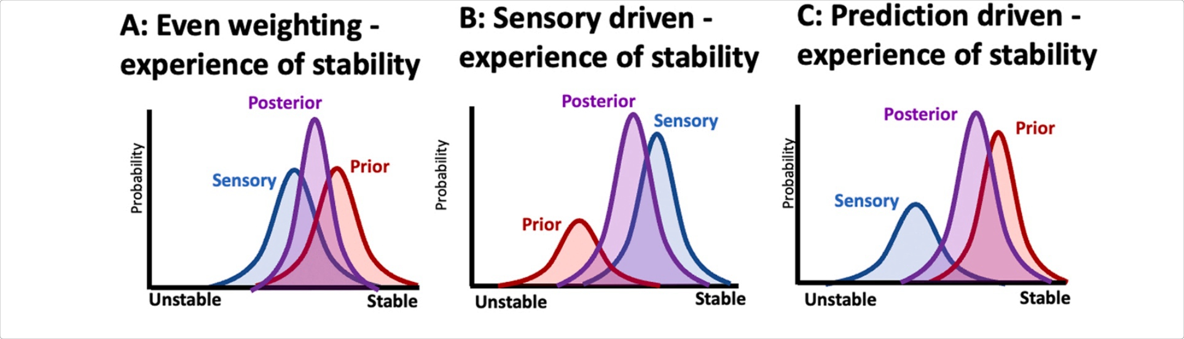
(A predictive processing perspective of disrupted motor control under anxiety .pdf, p.5)

Object Group

Excerpt: individual differences in cognitive abilities such as working memory and attentional capacity affect human-robot interaction and trust.
(Trust in Human-Robot Interaction -- Chang S. Nam, Joseph B. Lyons -- ( WeLib.org ).pdf, p.143)

Excerpt: Individuals with lower attentional resources rely more on automation.
(Trust in Human-Robot Interaction -- Chang S. Nam, Joseph B. Lyons -- ( WeLib.org ).pdf, p.140)

Excerpt: mentally occupied implies active use of attention, resulting in fewer attentional resources left over for other processes such as processing anxiety.
()

Excerpt: This suggests that being mentally occupied can lower the feeling or brain response of anxiety.
(Levels of appraisal- A medial prefrontal role in high-level appraisal of emotional material.pdf, p.1)

Object Group

Excerpt: While complete embodiment can’t be expected due to the bulkiness, rigidity, and other characteristics of exoskeleton, it is possible to some degrees.
(Quantitative assessment of human-exoskeleton integration through a neurophysiological marker of embodiment.pdf, p.7)

Excerpt: physiological measures of embodiment
(Embodiment_for_Robotic_Lower-Limb_Exoskeleton.pdf, p.6)

Excerpt: N60 (middle‑latency SSEP) is identified as a quantitative EEG marker of embodiment.
(Quantitative assessment of human-exoskeleton integration through a neurophysiological marker of embodiment.pdf, p.7)

Excerpt: Secondary index — N100: central negative peak (~100 ms) that is more negative for external stimulation, interpreted as an index of attentional orienting to externally generated stimuli; N100 correlates with subjective intensity ratings and helps dissociate attention from pure prediction effects.
(Quantitative assessment of human-exoskeleton integration through a neurophysiological marker of embodiment.pdf, p.7)

Excerpt: N100 is a marker of attention orientation to external somatosensory stimuli, which mediates the perception of stimulus intensity
(Quantitative assessment of human-exoskeleton integration through a neurophysiological marker of embodiment.pdf, p.7)

Excerpt: the greater mismatch between predicted and actual sensory input in these conditions likely increases demands on attentional resources.
(Quantitative assessment of human-exoskeleton integration through a neurophysiological marker of embodiment.pdf, p.7)

Excerpt: findings provide strong evidence for an up-weighting of sensory input during situations of high uncertainty.
-> even small prediction errors cause changes in perceptions
-> smaller errors will be perceived more easily
-> triggering rapid, reflexive actions to counteract the perceived disturbance and minimize the error
(A predictive processing perspective of disrupted motor control under anxiety .pdf, p.5)

Excerpt: By contrast, in non-exoskeleton conditions, more accurate sensorimotor predictions reduce the need for such attentional shifts, leading to diminished modulation of perceived stimulus intensity
(Quantitative assessment of human-exoskeleton integration through a neurophysiological marker of embodiment.pdf, p.7)

Excerpt: sensorimotor mismatch induces self-perceived anxiety and disrupts automatic motor control processes.
(Sensorimotor mismatch disrupts motor automaticity and increases anxiety during a goal-directed balance task.pdf, p.2)

Object Group

Excerpt: Predictive processing Definition of anxiety:
a state of hypervigilance where the world is viewed as more uncertain and the agent can no longer predict the absence of threats with confidence.
(A predictive processing perspective of disrupted motor control under anxiety .pdf, p.3)

Excerpt: Anxiety is activated when anticipated events or circumstances are perceived to be unpredictable, uncontrollable events.
(Cognitive Therapy of Anxiety Disorders - Science and -- Guilford Press.;Beck, Aaron Temkin;Clark, David A -- ( WeLib.org ).pdf, p.18)

Excerpt: Anxiety is an evaluation in low-level (automatic, preattentive) and high-level (requiring attention and working memory) appraisal processes.
(Levels of appraisal- A medial prefrontal role in high-level appraisal of emotional material.pdf, p.1)

Excerpt: In the context of appraisal anxiety, primary appraisal assesses the situation's potential threat or challenge.
()

Excerpt: As a result, anxious agents seek to reduce the perceived unpredictability of the world, and the associated uncertainty about their perceptions, either through action or revising their beliefs
(A predictive processing perspective of disrupted motor control under anxiety .pdf, p.4)

Excerpt: Secondary appraisal influences the individual's perception of control over the situation
source: Consensus/Appraisal-based definition and Components of the Appraisal Process of anxiety
()

Excerpt: one strategy to resolve uncertainty about negative outcomes is increased attention to threat-related cues which further perpetuates feelings perceived uncertainty.
(A predictive processing perspective of disrupted motor control under anxiety .pdf, p.4)

Excerpt: Anxiety induces a more conscious mode of action control.
(A predictive processing perspective of disrupted motor control under anxiety .pdf, p.8)

Excerpt: a qualitative study found that simply wearing a heavy exoskeleton makes users constantly aware of the device, heightening their overall sensory awareness
(Quantitative assessment of human-exoskeleton integration through a neurophysiological marker of embodiment.pdf, p.7)

Excerpt: Anxiety levels, motivation, and the sense of control are also involved in the subjective perception of exoskeleton usability
(Human–Robot Interactions- A Pilot Study of Psychoaffective and Cognitive Factors to Boost the Acceptance and Usability of Assistive Wearable Devices.pdf, p.2)

Excerpt: trait anxiety levels were predictive of the experienced effort
state anxiety score was predictive of the perceived workload using the exoskeleton
(Human–Robot Interactions- A Pilot Study of Psychoaffective and Cognitive Factors to Boost the Acceptance and Usability of Assistive Wearable Devices.pdf, p.1)

Excerpt: The amount of cognitive load required to use an exoskeleton should be managed to not affect functionality.
(Embodiment_for_Robotic_Lower-Limb_Exoskeleton.pdf, p.5)

Excerpt: Summary of the chain:
predictive processing defines anxiety as sensorimotor prediction error, exoskeleton use creates exactly that mismatch, the mismatch degrades proprioception, degraded proprioception breaks the sense of agency, broken agency collapses embodiment, and collapsed embodiment is what trust failure looks like from the inside of a body wearing a robot.
()

Object Group

Excerpt: the uncontrollable shock (or defeat) now activates the prelimbic-to dorsal raphe nucleus inhibitory pathway, even though without the prior immunizing experience of escapable shock (even seven days earlier) it would not do so.
(Learned helplessness at fifty- Insights from neuroscience.pdf, p.30)

Excerpt: Initial exposure to escapable shock prevents or reduces the passivity/anxiety induced by later inescapable shock, a phenomenon we called immunization
(Learned helplessness at fifty- Insights from neuroscience.pdf, p.30)

Object Group

Excerpt: measure state anxiety in real time during lower-limb exoskeleton use
()

Excerpt: using heart rate variability and galvanic skin response
()

Excerpt: This signal will be used to modulate the robot's level of autonomous assistance: as estimated anxiety rises above a threshold, the controller reduces its authority and returns agency to the user, directly targeting the sense of agency component of embodiment.
()

Excerpt: Across sessions, participants will be exposed to a graduated protocol of brief, escapable robot perturbations — moments where the system behaves unexpectedly but the user can immediately switch to manual mode — grounded in the immunization paradigm from learned helplessness research, which predicts that prior experience with controllable adversity reduces the anxiety response to later uncontrollable events
()

Excerpt: The primary outcome = change in exoskeleton embodiment over sessions
measured via
()

Excerpt: the N60 SSEP marker as a neurophysiological index
()

Excerpt: trust calibration and perceived workload
()

Excerpt: Conclusion
()

Excerpt: The central hypothesis:
anxiety-driven adaptive control, combined with graduated escapable failure exposure, will produce stronger and more durable embodiment than either a smooth, failure-free condition or uncontrolled failure, because it trains the user's predictive model of the robot rather than simply avoiding mismatch.
()

Excerpt: While physiological signals such as HRV and EDA have been used as correlates of trust in collaborative robotics, no existing work has applied these measures to body-coupled wearable systems such as lower-limb exoskeletons, nor has any work provided a mechanistic explanation for why these signals track trust in the first place.
This thesis proposes that anxiety — understood through predictive processing and polyvagal theory as the brain's response to unresolved sensorimotor uncertainty — is not merely correlated with trust loss in wearable robots, but is its primary causal substrate: when the exoskeleton violates the user's forward model of their own body, the resulting mismatch between neuroception and interoception triggers an autonomic anxiety response that narrows attention, degrades automatic motor control, and reduces embodiment, producing exactly the trust dynamics observed in the HRI literature.
Because anxiety is neurologically grounded, objectively measurable in real time, and causally upstream of both embodiment and trust, it offers something the existing trust literature cannot — a single, closed-loop feedback variable that tells the controller not just that trust has been lost, but why, when, and by how much, enabling principled, real-time adaptation of assistance level rather than post-hoc redesign.
()

Excerpt: Anxiety roots in how the brain processes and appraises threat-related information.
(Levels of appraisal- A medial prefrontal role in high-level appraisal of emotional material.pdf, p.1)

Workspace - Workspace 1

Excerpt: Summary
()

Excerpt: A tickling method for measuring/detecting disembodiment
(Embodiment_for_Robotic_Lower-Limb_Exoskeleton.pdf, p.4)

Object Group

Excerpt: Embodiment is an understudied but important aspect of human adaptation to exoskeletons. Qualitative and quantitative measures of embodiment have been used to assess integration of prostheses and tools into the body schema of users indicate that embodiment of robotic movement devices improves the functionality of these devices
(Embodiment_for_Robotic_Lower-Limb_Exoskeleton.pdf, p.9)

Excerpt: Sense of Embodiment consists of three subcomponents:
the sense of self-location,
the sense of agency,
and the sense of body ownership.
(The Sense of Embodiment in Virtual Reality.pdf, p.1)

Excerpt: The more expected movement and actual movement match (i.e., spatiotemporal congruency), the more the subject experiences a sense of agency over that movement, a sense of self-location with the body part or tool used, and a sense of ownership over the action. In contrast, a consistent mismatch will lead to a decreased tool embodiment.
(Quantitative assessment of human-exoskeleton integration through a neurophysiological marker of embodiment.pdf, p.2)

Excerpt: While complete embodiment can’t be expected due to the bulkiness, rigidity, and other characteristics of exoskeleton, it is possible to some degrees.
(Quantitative assessment of human-exoskeleton integration through a neurophysiological marker of embodiment.pdf, p.7)

Excerpt: [Image]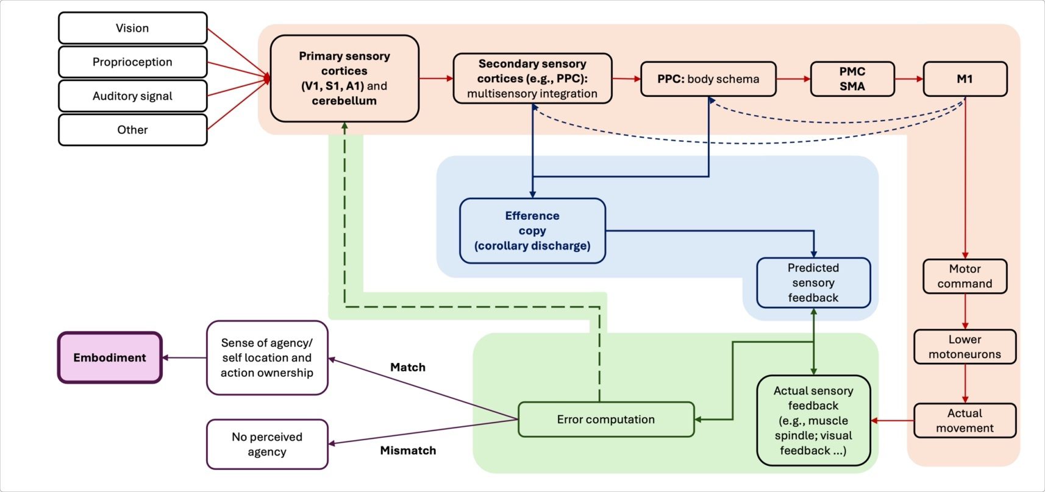
(Quantitative assessment of human-exoskeleton integration through a neurophysiological marker of embodiment.pdf, p.2)

Excerpt: Simply wearing an exoskeleton can alter proprioceptive feedback.
(Quantitative assessment of human-exoskeleton integration through a neurophysiological marker of embodiment.pdf, p.7)

Excerpt: Proprioception is the sensory mediator for the "Sense of Agency"; without precise proprioceptive feedback, the user cannot achieve the psychological state of "human-in-the-loop" trust.
Caspar, E. A., et al. (2018). The influence of user-compliant control strategies on the sense of agency in wearable robotics. *Journal of NeuroEngineering and Rehabilitation*.
()

Excerpt: [Image]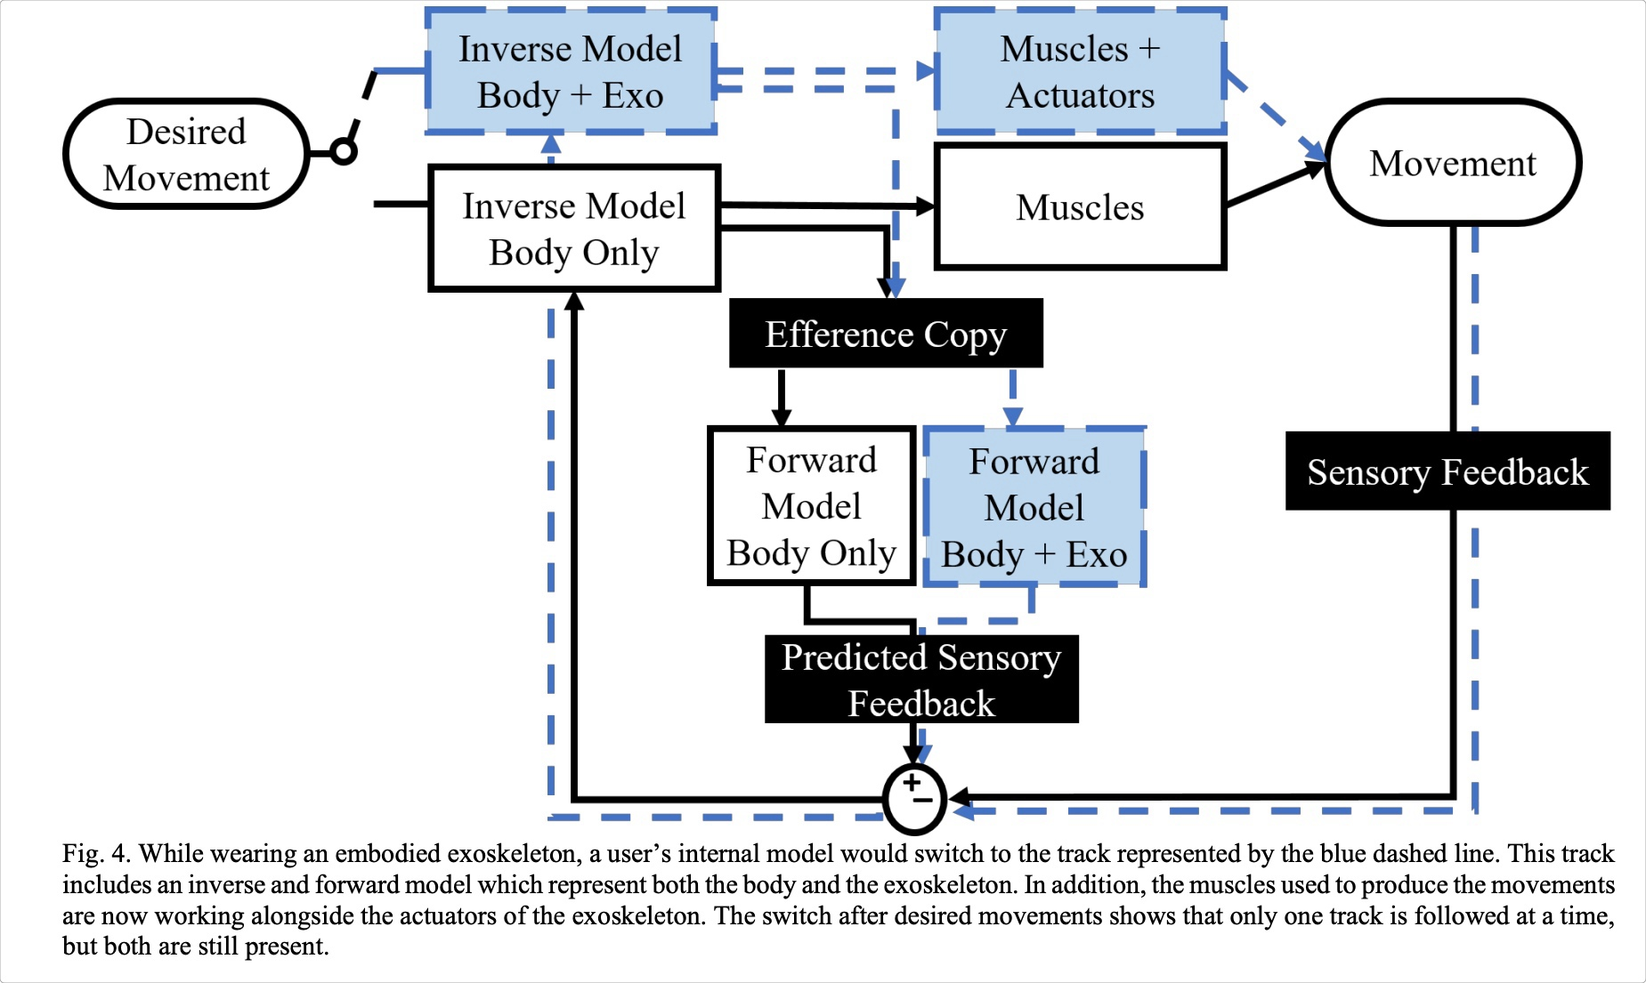
(Embodiment_for_Robotic_Lower-Limb_Exoskeleton.pdf, p.5)

Object Group

Comment: Source: Cognitive Therapy of Anxiety Disorders
(Refers to a comment with text: '(null)')

Excerpt: [Image]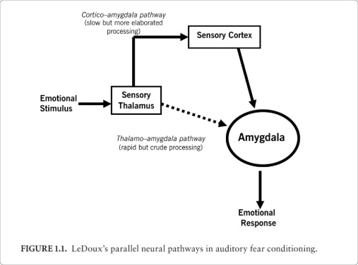
()

Object Group

Excerpt: Performing a task quickly as well as accurately has been interpreted as a sign of increased embodiment of the object used in the task
(Embodiment_for_Robotic_Lower-Limb_Exoskeleton.pdf, p.6)

Excerpt: sensory perception or motor performance outcomes
Proprioceptive drift, for instance, is the measured difference between the actual location of a body part and the point where a person perceives that body part to be in space.
(Embodiment_for_Robotic_Lower-Limb_Exoskeleton.pdf, p.6)

Excerpt: movement velocity
(Embodiment_for_Robotic_Lower-Limb_Exoskeleton.pdf, p.6)

Excerpt: physiological measures of embodiment
(Embodiment_for_Robotic_Lower-Limb_Exoskeleton.pdf, p.6)

Excerpt: reaction time
(Embodiment_for_Robotic_Lower-Limb_Exoskeleton.pdf, p.6)

Excerpt: postural sway
(Embodiment_for_Robotic_Lower-Limb_Exoskeleton.pdf, p.6)

Excerpt: N60 (middle‑latency SSEP) is identified as a quantitative EEG marker of embodiment.
(Quantitative assessment of human-exoskeleton integration through a neurophysiological marker of embodiment.pdf, p.7)

Excerpt: Tonic heart rate refers to the sustained, resting, or baseline level of heart rate, while phasic heart rate refers to rapid, transient changes in heart rate that occur in response to specific stimuli.
()

Excerpt: subjective anxiety was associated with a trend-level increase in effort ratings
(Levels of appraisal- A medial prefrontal role in high-level appraisal of emotional material.pdf, p.4)

Excerpt: Increased cognitive load
(Levels of appraisal- A medial prefrontal role in high-level appraisal of emotional material.pdf, p.4)

Excerpt: The amount of cognitive load required to use an exoskeleton should not cause an increase in errors or a decrease in function in other important daily tasks
(Embodiment_for_Robotic_Lower-Limb_Exoskeleton.pdf, p.5)

Excerpt: While trait anxiety levels were predictive of the experienced effort, the state anxiety score was predictive of the perceived workload
(Human–Robot Interactions- A Pilot Study of Psychoaffective and Cognitive Factors to Boost the Acceptance and Usability of Assistive Wearable Devices.pdf, p.1)

Excerpt: a qualitative study found that simply wearing a heavy exoskeleton makes users constantly aware of the device, heightening their overall sensory awareness
(Quantitative assessment of human-exoskeleton integration through a neurophysiological marker of embodiment.pdf, p.7)

Excerpt: one strategy to resolve uncertainty about negative outcomes is increased attention to threat-related cues (Bar-Haim et al., 2007).
But attention to threat-related cues only serves to further increase estimates of the likelihood of negative outcomes, which further perpetuates feelings of anxiety and the persistence of perceived uncertainty
(A predictive processing perspective of disrupted motor control under anxiety .pdf, p.4)

Excerpt: Research on attention orienting in the somatosensory modality has shown that the N100 is a marker of attention orientation to external somatosensory stimuli, which mediates the perception of stimulus intensity
(Quantitative assessment of human-exoskeleton integration through a neurophysiological marker of embodiment.pdf, p.7)

Excerpt: Secondary index — N100: central negative peak (~100 ms) that is more negative for external stimulation, interpreted as an index of attentional orienting to externally generated stimuli; N100 correlates with subjective intensity ratings and helps dissociate attention from pure prediction effects.
(Quantitative assessment of human-exoskeleton integration through a neurophysiological marker of embodiment.pdf, p.7)

Excerpt: the greater mismatch between predicted and actual sensory input in these conditions likely increases demands on attentional resources.
(Quantitative assessment of human-exoskeleton integration through a neurophysiological marker of embodiment.pdf, p.7)

Excerpt: Within PP accounts, anxiety – which is traditionally described as a negative emotional response to threat consisting of cognitive worry and physiological arousal (Eysenck, 2013) – is recast as a state of hypervigilance where the world is viewed as more uncertain and the agent can no longer predict the absence of threats with confidence.
(A predictive processing perspective of disrupted motor control under anxiety .pdf, p.3)

Excerpt: sensorimotor mismatch induces self-perceived anxiety and disrupts automatic motor control processes.
(Sensorimotor mismatch disrupts motor automaticity and increases anxiety during a goal-directed balance task.pdf, p.2)

Excerpt: Anxiety is activated when anticipated events or circumstances are perceived to be unpredictable, uncontrollable events.
(Cognitive Therapy of Anxiety Disorders - Science and -- Guilford Press.;Beck, Aaron Temkin;Clark, David A -- ( WeLib.org ).pdf, p.18)

Excerpt: Clark, Watson, and Friston (2018) describe anxiety not only as a state of uncertainty, but as a generalised expectation of uncertainty (about potential threats in the world and our ability to anticipate them) that is held with low precision
(A predictive processing perspective of disrupted motor control under anxiety .pdf, p.4)

Excerpt: The presence of control, actively inhibits the default passivity response by engaging the vmPFC-DRN pathway
()

Excerpt: [Image]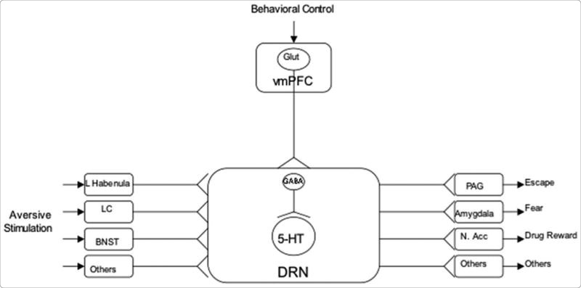
()

Excerpt: If the user does not have agency over the controller or the controller is not transparent to the user, the user would have a more difficult time developing (an) appropriate internal model(s) to reflect the altered limb dynamics with the exoskeleton
(Embodiment_for_Robotic_Lower-Limb_Exoskeleton.pdf, p.5)

Excerpt: the prelimbic cortex (PrL) of the mPFC is thought to modulate anxiety-related behaviors
(Prelimbic Cortex Activity Predicts Anxiety-Like Behavior in the Elevated Plus Maze.pdf, p.2)

Excerpt: PrL receives convergent input from frontal areas, visual and auditory cortices, hippocampus, amygdala, thalamus, and hypothalamus (Conde et al., 1995).
Thus, PL output likely reflects the integration of contextual, motivational, and mnemonic information.
(Activity in Prelimbic Cortex Is Necessary for the Expression of Learned, But Not Innate, Fears.pdf, p.4)

Excerpt: On the brain sections:
The vmPFC is reciprocally connected to the basobasolateral amygdala, and this vmPFC-amygdala pathway is directly relevant to anxiety, particularly in the context of extinction learning — which is essentially what your immunization protocol is asking the brain to do. Deficient safety learning specifically reflects disrupted inhibitory vmPFC-amygdala circuitry, and amygdala hyperactivity leads to increased vigilance, biased attention toward threat, and deficient associative learning — all of which contribute to a feedback loop of heightened threat expectancy. And your note about trust tendency correlating with gray matter in the vmPFC is confirmed by the broader picture: neural sensitivity to threat in vmPFC correlates with self-reported state anxiety across individuals, and the vmPFC functions to defend the organism from acute stress while also facilita reward processes. That last part is key for you — it means the vmPFC is literally the brain region sitting at the intersection of threat, control, and reward, which is exactly the intersection theewhole framework is built on.
()

Excerpt: Activation of the SNS (sympathetic nervous system) is the most prominent physiological response in anxiety, and it leads to hyperarousal symptoms.
(Cognitive Therapy of Anxiety Disorders - Science and -- Guilford Press.;Beck, Aaron Temkin;Clark, David A -- ( WeLib.org ).pdf, p.29)

Excerpt: As a result, anxious agents seek to reduce the perceived unpredictability of the world, and the associated uncertainty about their perceptions, either through action or revising their beliefs
(A predictive processing perspective of disrupted motor control under anxiety .pdf, p.4)

Excerpt: In humans, mPFC is important for evaluating emotionally salient stimuli to select appropriate actions
(Activity in Prelimbic Cortex Is Necessary for the Expression of Learned, But Not Innate, Fears.pdf, p.4)

Excerpt: individual differences in the tendency to trust are associated with regional gray matter volume within the ventromedial prefrontal cortex (vmPFC), amygdala and anterior insula
(The tendency to trust is reflected in human brain structure.pdf, p.1)

Excerpt: N1 responses were strongly correlated with fear of falling + confidence in balance
(A predictive processing perspective of disrupted motor control under anxiety .pdf, p.4)

Excerpt: Receptors that are engaged in keeping body balanced, tend to adjust more quickly to external stimuli. (Respond faster to intensity and frequency of signals).
On the contrary, receptors regarding proprioception react slower.
(Neuroanatomy, Somatosensory Cortex - StatPearls - NCBI Bookshelf.pdf, p.3)

Excerpt: Anxiety levels, motivation, and the sense of control are also involved in the subjective perception of exoskeleton usability
(Human–Robot Interactions- A Pilot Study of Psychoaffective and Cognitive Factors to Boost the Acceptance and Usability of Assistive Wearable Devices.pdf, p.2)

Excerpt: We have suggested that the PP conceptualization of anxiety as a state of uncertainty explains common observations of spiralling skill-focused attention and movement monitoring via changes in precision weighting of predictions and sensory prediction errors.
The result is movement that is too reactive and devoid of normal predictive guidance.
(A predictive processing perspective of disrupted motor control under anxiety .pdf, p.9)

Excerpt: Anxiety appraisal is defined as the cognitive evaluation of emotional stimuli that influences the generation of an emotional response, with distinctions between low-level (automatic, preattentive) and high-level (requiring attention and working memory) appraisal processes
(Levels of appraisal- A medial prefrontal role in high-level appraisal of emotional material.pdf, p.1)

Excerpt: Combined, we believe that these findings provide strong evidence for an up-weighting of sensory input (and a concomitant reduction in the precision afforded to prior beliefs about stability) during situations of high uncertainty about stability.
This has the effect of allowing even small prediction errors to ascend to higher levels of the nervous system, leading to changes in perceptions of stability.
In other words, deviations in stability will be perceived more easily, resulting in the triggering of rapid, reflexive actions to counteract the perceived postural disturbance and minimise the error signal.
(A predictive processing perspective of disrupted motor control under anxiety .pdf, p.5)

Excerpt: [Image]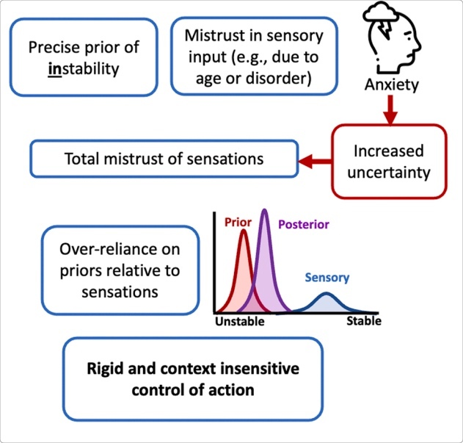
(A predictive processing perspective of disrupted motor control under anxiety .pdf, p.5)

Excerpt: By contrast, in non-exoskeleton conditions, more accurate sensorimotor predictions reduce the need for such attentional shifts, leading to diminished modulation of perceived stimulus intensity
(Quantitative assessment of human-exoskeleton integration through a neurophysiological marker of embodiment.pdf, p.7)

Excerpt: [Image]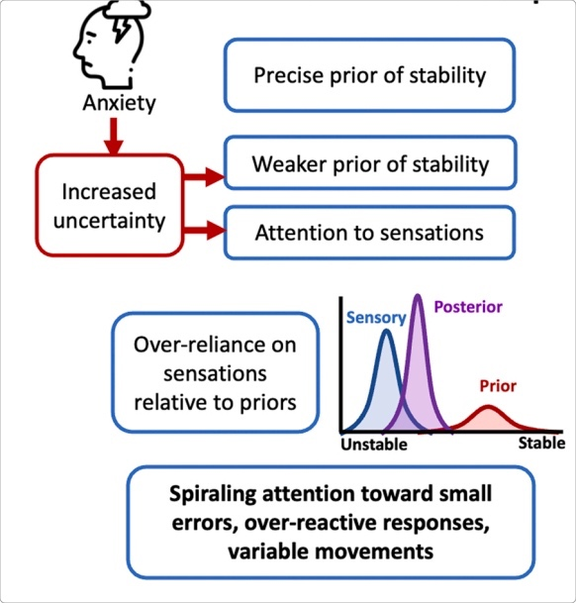
(A predictive processing perspective of disrupted motor control under anxiety .pdf, p.5)

Excerpt: It also caused a strong trend-level increase in tonic heart rate levels and in initial phasic heart rate responses to the onset of pain cues
(Levels of appraisal- A medial prefrontal role in high-level appraisal of emotional material.pdf, p.4)

Excerpt: The anterior insula is involved in emotional awareness and the subjective experience of emotions
(The tendency to trust is reflected in human brain structure.pdf, p.2)

Excerpt: PrL integrates information from auditory and contextual inputs and regulates expression of Prior fear memories via projections to the basal nucleus of the amygdala.
(Activity in Prelimbic Cortex Is Necessary for the Expression of Learned, But Not Innate, Fears.pdf, p.1)

Object Group

Excerpt: [Image]
(A predictive processing perspective of disrupted motor control under anxiety .pdf, p.5)

Excerpt: The S2 region has links to the hippocampus and amygdala; this helps us receive information from our environments and make decisions on how to approach them by integrating our prior stored experience, factoring our current appraisal of the stimulus
(Neuroanatomy, Somatosensory Cortex - StatPearls - NCBI Bookshelf.pdf, p.1)

Excerpt: The primary somatosensory cortex receives sensory information from VPL of the thalamus.
(Neuroanatomy, Somatosensory Cortex - StatPearls - NCBI Bookshelf.pdf, p.1)

Excerpt: Aka., postcentral gyrus
(Neuroanatomy, Somatosensory Cortex - StatPearls - NCBI Bookshelf.pdf, p.1)

Excerpt: Initial exposure to escapable shock prevents or reduces the passivity/anxiety induced by later inescapable shock, a phenomenon we called immunization
(Learned helplessness at fifty- Insights from neuroscience.pdf, p.30)

Excerpt: the uncontrollable shock (or defeat) now activates the prelimbic-to dorsal raphe nucleus inhibitory pathway, even though without the prior immunizing experience of escapable shock (even seven days earlier) it would not do so.
(Learned helplessness at fifty- Insights from neuroscience.pdf, p.30)

Excerpt: high-level appraisal that requires attentional and working memory resources.
When a person is busy with a demanding mental task (high cognitive load), anxiety-related brain activity in these areas is reduced.
This suggests that being mentally occupied can lower the feeling or brain response of anxiety.
(Levels of appraisal- A medial prefrontal role in high-level appraisal of emotional material.pdf, p.1)

Excerpt: Appraisal refers to the evaluation of the meaning of emotional stimuli
(Levels of appraisal- A medial prefrontal role in high-level appraisal of emotional material.pdf, p.1)

Excerpt: low-level appraisal, considered to be automatic and preattentive
(Levels of appraisal- A medial prefrontal role in high-level appraisal of emotional material.pdf, p.1)

Excerpt: State Anxiety causes:
Higher regional activity levels in Right postcentral gyrus (somatosensory cortex).
Right precentral gyrus (motor cortex).
Stronger connections between the postcentral gyrus and the left cerebellum gyrus, and weaker connections between the postcentral gyrus and Left inferior, Left medial frontal cortex superior frontal cortex.
(The Altered Somatic Brain Network in State Anxiety.pdf, p.1)

Excerpt: anxious individuals may experience stronger brain-body signaling, which could explain why anxiety often comes with physical sensations (like tension, restlessness, or discomfort).
At the same time, reduced connectivity with frontal regions (involved in regulation and control) may mean less top-down regulation of these body signals — making anxiety harder to manage.
()

Object Group

Excerpt: Studies demonstrated that individuals with lower attentional resources showed increased reliance on automation, and operators increased their reliance on automation when less attentional resources were available
(Trust in Human-Robot Interaction -- Chang S. Nam, Joseph B. Lyons -- ( WeLib.org ).pdf, p.140)

Excerpt: individual differences in cognitive abilities such as working memory and attentional capacity affect human-robot interaction and trust.
(Trust in Human-Robot Interaction -- Chang S. Nam, Joseph B. Lyons -- ( WeLib.org ).pdf, p.143)

Excerpt: Trust can be defined as “a person’s calculated exposure to risk of damage from the activities of influential others”
(Trust in Human-Robot Interaction -- Chang S. Nam, Joseph B. Lyons -- ( WeLib.org ).pdf, p.152)

Excerpt: In the literature on trust in automation, the primary focus is on appropriately matching expectations for a system with information about the performance of the system
(Trust in Human-Robot Interaction -- Chang S. Nam, Joseph B. Lyons -- ( WeLib.org ).pdf, p.20)

Excerpt: These systems are motiveless, and users are not concerned about being betrayed, exploited, or deceived by the system.
Trust here is the expectation that a system will perform a task as intended and expected, and the only worries that arise concern the system’s reliability and ability.
(Trust in Human-Robot Interaction -- Chang S. Nam, Joseph B. Lyons -- ( WeLib.org ).pdf, p.21)

Excerpt: Early in the relationship (No priors), the trust in the system is based on the predictability of the system’s behavior.
(Foundations of Trusted Autonomy.pdf, p.150)

Excerpt: when people have prior knowledge of faults, these faults do not necessarily diminish trust in the system.
(Foundations of Trusted Autonomy.pdf, p.152)

Excerpt: these experiences lead to expectations on process
(Measuring Trust for Exoskeleton Systems.pdf, p.2)

Excerpt: that faults of varying (unpredictable) magnitude diminished trust more than large constant faults
(Foundations of Trusted Autonomy.pdf, p.151)

Excerpt: This disconnect between human expectation and system feedback was observed when some participants believed they had fully relaxed their muscles when their muscles still maintained a low activation.
(Measuring Trust for Exoskeleton Systems.pdf, p.1)

Excerpt: When a robot fails to meet the user’s expectations, trust is impacted. These expectations may include the spatial motion of the robot, the verbal or non-verbal feedback, or the order of a task procedure.
(Measuring Trust for Exoskeleton Systems.pdf, p.1)

Excerpt: Trust in exoskeletons is grouped into purpose, process, and performance
(Measuring Trust for Exoskeleton Systems.pdf, p.1)

Excerpt: learned trust, is based on past experiences relevant to a specific automated system
(Trust in Automation- Integrating Empirical Evidence on Factors That Influence Trust.pdf, p.7)

Object Group

Excerpt: Excessively up-weight the influence of sensory prediction errors during situations of uncertainty, particularly if sensory input is increasingly noisy or imprecise (as often is the case in older adults).
(A predictive processing perspective of disrupted motor control under anxiety .pdf, p.8)

Excerpt: Practical recommendations
(A predictive processing perspective of disrupted motor control under anxiety .pdf, p.8)

Excerpt: Adopt highly precise – yet incorrect – predictions about movement capability (i.e., over- or under-estimated stability/risk of falling).
(A predictive processing perspective of disrupted motor control under anxiety .pdf, p.9)

Excerpt: It is also well-established that anxiety induces a more conscious mode of action control.
We expect that this would hold for predictions about motor movements under anxiety
(A predictive processing perspective of disrupted motor control under anxiety .pdf, p.8)

Excerpt: Utilise overly rigid and simplified movement strategies, while ignoring sensory feedback that could help to better regulate movement.
(A predictive processing perspective of disrupted motor control under anxiety .pdf, p.9)

